II B. Tech. I Semester Regular Examinations – January, 2023
DIGITAL LOGIC & COMPUTER ORGANIZATION
(cse(CS))
Time: 150 Min Max. Marks: 80M

SECTION – A
Answer all Four questions 4×10M=40M

- Design a combinational circuit with three inputs, x, y, and z, and three outputs, A, B, and C. When the binary input is 0, 1, 2, or 3, the binary output is one greater than the input. When the binary input is 4, 5, 6, or 7, the binary output is two less than the input.

- A majority circuit is a combinational circuit whose output is equal to 1 if the input variables have more 1’s than 0’s. The output is 0 otherwise. Design a 3-input majority circuit by finding the circuit’s truth table, Boolean equation, and a logic diagram.

- Design a half- subtractor circuit with inputs x and y and outputs Diff and B out. The circuit subtracts the bits x – y and places the difference in D and borrow in B out. Design a full- subtractor circuit with three inputs x, y, B in and two outputs Diff and B out. The circuit subtracts x – y – B in, where B in is the input borrow, B out is the output borrow, and Diff is the difference.

- Consider the following register transfer statements for two 4-bit registers R1 and R2.
xT: R1← R1+ R2 : Add R2 to R1
x’T: R1← R2 : Transfer R2 to R1
Every time the variable T=1, and the content of R2 is added to the R1 if x=1 or the content of R2 is transferred to R1 if x=0. Draw a diagram showing the hardware implementation of the two statements. Use the diagrams of 4- bit adder, 4- bit register and a quadruple 2 to 1 line multiplexer that selects the inputs to R1. Show how the control variables x and T selects the inputs of multiplexer and load input of register R1.

SECTION-B
Answer all Two questions 2×20M=40M

- Consider the combinational circuit shown in Fig.1
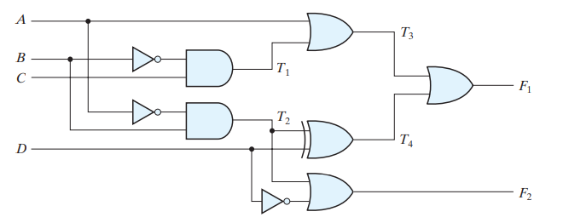
- Derive the Boolean expressions for T1 through T4. Evaluate the outputs F1 and F2 as a function of the four inputs.
- List the truth table with 16 binary combinations of the four input variables. Then list the binary values for T1 through T4 and outputs F1 and F2 in the table.
- Plot the output Boolean functions obtained in part (b) on maps and show that the simplified Boolean expressions are equivalent to the ones obtained in part (a).

- A computer system employs RAM chips of 256 X 8 and ROM chips of 1024 X 8. The computer system needs 2K bytes of RAM, 4K bytes of ROM and four interface units each with four registers. A memory mapped I/O configuration is used. The highest order bits of the address bus are assigned 10 for RAM, 00 for ROM and 01 for interface registers.
- How many RAM and ROM chips are needed?
- Draw memory address map for the system.
- Give the address range in hexadecimal for RAM, ROM and interface.

